Multiple-choice section – choose the correct answer

Question 1 [11.1]

Which of the following are irrational numbers?

, 4.5, , , 

A only B ,and  C , 4.5 and  D and

Question 2 [11.1]

The value of  is between:

A 4 and 5 B 8 and 9 C 10 and 7 D 16.9 and 17.1

Question 3 [11.2]

 can be simplified to:

**A** 14 **B** 2 **C** 2 **D**  4

Question 4 [11.2]

6 × 5 can be simplified to:

**A** 180 **B** 30 **C** 18 **D** 10

Question 5 [11.3]

7 – 3simplifies to:

A 4 B 4 C 8 D 5

Multiple-choice results: ___ / 5

Short answer section

Question 6 2 marks [11.1]

Choose from the following words to complete the sentences below.

base coefficient index irrational number power surd

 is an example of a _________ or an __________________________.

Question 7 3 marks [11.3]

Simplify: + 3

Question 8 4 marks [11.4]

Expand and simplify 2(3 + ).

Question 9 2 marks [11.2]

Express 7as an entire surd.

Question 10 3 marks [11.3]

Find the exact area of a circle with radius 2 mm.

Question 11 5 marks [11.5]

Write as single fractions with rational denominators:

(a)  (b) 

Short answer results: ___ / 19

Extended answer section

Question 12 8 marks [11.2, 11.3]

Write the answers to the following in simplest exact form.

(a) Find the area of a circle of radius  + 2 cm.

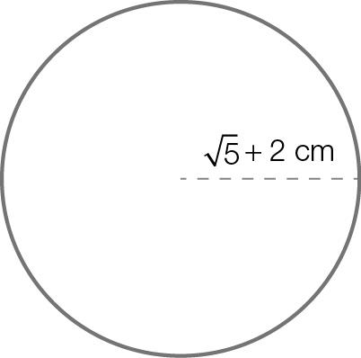

(b) Find the surface area of a cylinder with circular base as given in (a) and height of 6 cm.

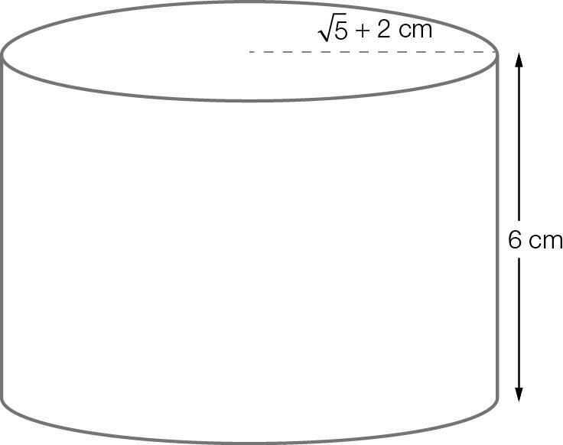

(c) Find the volume of the cylinder given in part (b).

Question 13 8 marks [11.2, 11.3]

A circular mirror is to be placed in the centre of a rectangular wall.  
The mirror has a radius of 20 cm. The distance from the top of the mirror to the ceiling is 1 m and from the bottom of the mirror to the floor is 1 m.  
From each side edge of the mirror to the closest edge of the wall is 2 m.

(a) Find the exact height of the wall in centimetres.

(b) Find the exact width of the wall in centimetres.

(c) Find the exact area of the wall in square centimetres.

(d) Find the area, in square metres and correct to 2 decimal places, of the exposed wall after the mirror is hung.

Extended answer results: ___ / 16

TOTAL test results: ___ / 40